**Program 6 - Order Database**

**Consider the following schema for Order Database:**

**SALESMAN (*Salesman_id, Name, City, Commission*)**

**CUSTOMER (*Customer_id, Cust_Name, City, Grade, Salesman_id*)**

**ORDERS (*Ord_No, Purchase_Amt, Ord_Date, Customer_id, Salesman_id*)**

create database Order;

use Order;

create table salesman (

salesman_id int,

name varchar (20),

city varchar (20),

commission varchar (20),

primary key (salesman_id));

desc salesman;

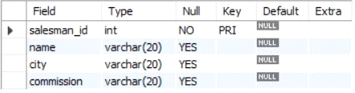

create table customer (

customer_id int,

cust_name varchar (20),

city varchar (20),

grade int ,

salesman_id int,

primary key (customer_id),

foreign key (salesman_id) references salesman(salesman_id) on delete set null);

desc customer;

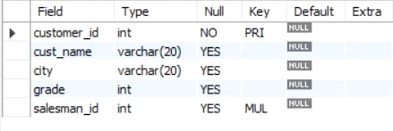

create table orders (

ord_no int ,

purchase_amt int,

ord_date date,

customer_id int,

salesman_id int,

primary key (ord_no),

foreign key (customer_id) references customer (customer_id) on delete cascade,

foreign key (salesman_id) references salesman (salesman_id) on delete cascade);

desc orders;

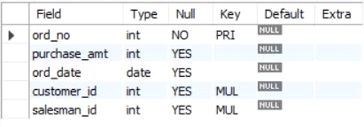

insert into salesman values (1000, 'john','bangalore','25 %');

insert into salesman values (2000, 'ravi','bangalore','20 %');

insert into salesman values (3000, 'kumar','mysore','15 %');

insert into salesman values (4000, 'smith','delhi','30 %');

insert into salesman values (5000, 'harsha','hydrabad','15 %');

select * from salesman;

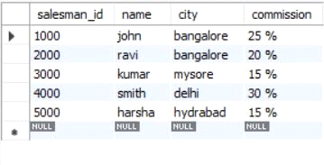

insert into customer values (10, 'preethi','bangalore', 100, 1000);

insert into customer values (11,'vivek','mangalore', 300, 1000);

insert into customer values (12, 'bhaskar','chennai', 400, 2000);

insert into customer values (13, 'chethan','bangalore', 200, 2000);

insert into customer values (14, 'mamatha','bangalore', 400, 3000);

select * from customer;

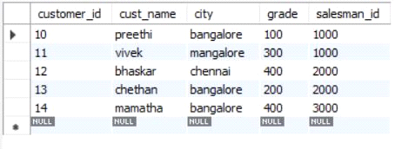

insert into orders values (50, 5000, '04-06-17', 10, 1000);

insert into orders values (51, 450, '20-01-17', 10, 2000);

insert into orders values (52, 1000, '24-02-17', 13, 2000);

insert into orders values (53, 3500, '13-04-17', 14, 3000);

insert into orders values (54, 550, '09-03-17', 12, 2000);

select * from orders;

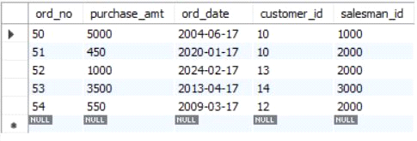

**1. Count the customers with grades above Bangalore’s average.**

SELECT grade, count(DISTINCT customer_id)

FROM customer

GROUP BY grade

HAVING grade > (SELECT AVG(grade)

FROM customer

WHERE city='bangalore');

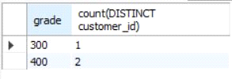

**2. Find the name and numbers of all salesmen who had more than one customer.**

SELECT salesman_id, NAME

FROM salesman a

WHERE 1 < (SELECT count(*)

FROM customer

WHERE salesman_id=a.salesman_id);

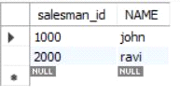

**3. List all salesmen and indicate those who have and don’t have customers in their cities (Use UNION operation.)**

SELECT salesman.salesman_id, NAME, cust_name, commission

FROM salesman, customer

WHERE salesman.city = customer.city

UNION

SELECT salesman_id, name, 'no customer', commission

FROM salesman

WHERE NOT city = ANY

(SELECT city

FROM customer)

ORDER BY 2 DESC;

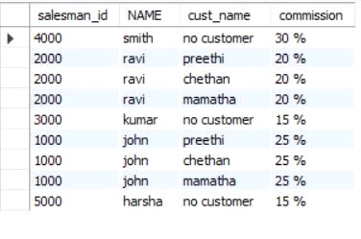

**4. Create a view that finds the salesman who has the customer with the highest order of a day.**

CREATE VIEW highsalesman AS

SELECT b.ord_date, a.salesman_id, a.name

FROM salesman a, orders b

WHERE a.salesman_id = b.salesman_id

AND b.purchase_amt=(SELECT max(purchase_amt)

FROM orders c

WHERE c.ord_date = b.ord_date);

SELECT * FROM highsalesman;

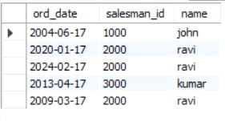

**5. Demonstrate the DELETE operation by removing salesman with id 1000. All his orders must also be deleted.**

DELETE FROM salesman

WHERE salesman_id=1000;

SELECT * FROM salesman;

SELECT * FROM orders;



